Task 1 Report - Learning a Programming Language
Student Name: amr khaled abu hattab
Chosen Programming Language: Java
Program Idea: A simple "To-Do List" management system based on Object-Oriented Programming (OOP) and dynamic list
- Learning Hours and Sources
Crash Course on the YouTube program, five hours
https://youtu.be/e-a7OiTmA64?si=WP_mdDDB5-B2sm8W
2. Explanation of the main Function in Java
The main function in Java is written as: public static void main(String[] args)
It is considered the "Entry Point" of any Java application. When the code runs, the Java Virtual Machine (JVM) looks for this exact method to start execution. Here is a breakdown of its components:
- public: An Access Modifier indicating that this function is accessible from anywhere. The JVM needs this to be public so it can execute the program from outside the class.
- static: This keyword means the method belongs to the class itself, rather than to a specific object (instance) of the class. This is necessary because the JVM needs to call the main method before any objects are created.
- void: The Return Type. It indicates that this method performs actions but does not return any value upon completion.
- main: The reserved programmatic name recognized by the system to begin executing the program.
- String[] args: An array of Strings. It is used to accept any command-line arguments (inputs) passed to the program when it is launched.
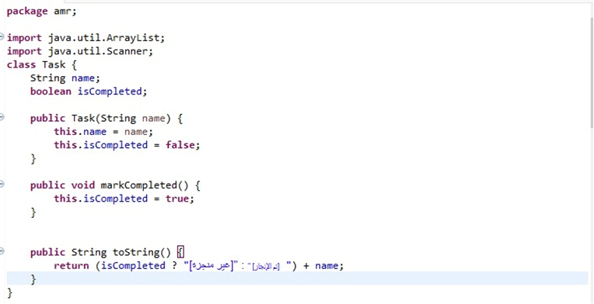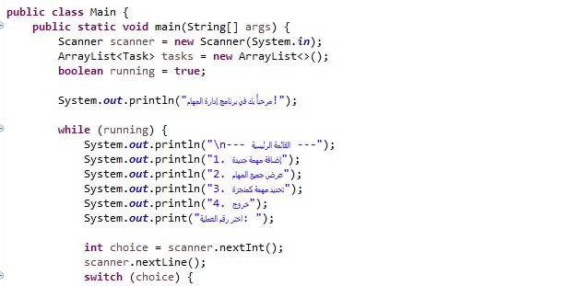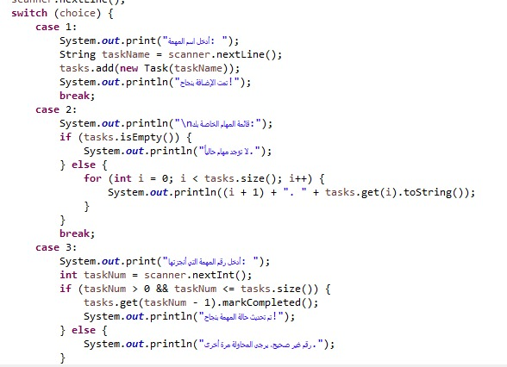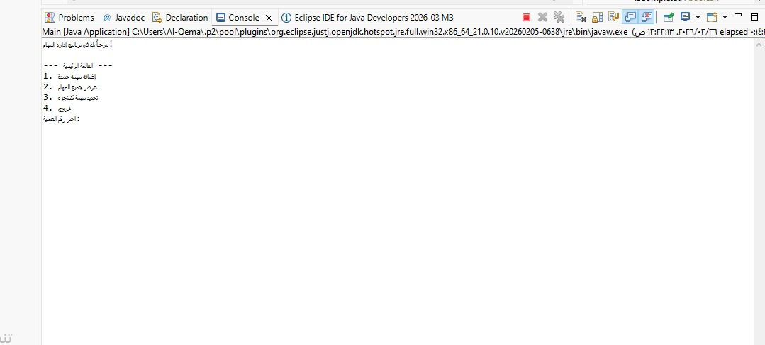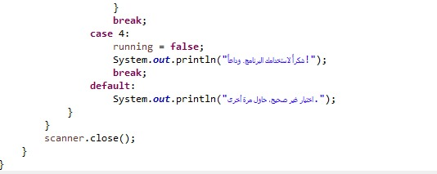

4-Video Link

https://youtu.be/9NJtHMmhO44?si=RZNdcMUmFwGP5e8Q

